Karan Sharma

November 11, 2013

Snapping Background Information

OpenStreetMap:

In order to understand how the snap functions work, one must first understand the underlying concepts at play. The first of these concepts is OpenStreetMap, which is the map service that provides the entire map data used in snap calculations. OpenStreetMap data is stored in .osm files, which are of XML format and can be found various places online. These files are massive, so they are often compressed as .bz2. To give some perspective on the size of the OSM data, “Planet.osm”, which contains the entire planets map data, is 370 GB or 27 GB when compressed. Due to this size, I downloaded the map data of the Pittsburgh area that is a more reasonable 92.4 MB, or 6 MB when compressed.

OSM Elements:

So now you know the data for snapping comes from .osm files, the next step is to understand how real world map data is stored within the files. The way OSM does this is by modeling the world’s streets using 4 basic elements: Nodes, Ways, Relations, and Tags. Nodes are individual geospatial points of longitude and latitude. These can be thought of as points on a graph. Ways are defined as an ordered list of Nodes. Essentially, these are vectors that connect the points on the graph. Ways come in 3 types: Open Polylines, Closed Polylines, and Areas. An Open Polyline is a Way where the endpoints are disconnected. These are the most common Ways, as they are used to map streets. A Closed Polyline is where the endpoints are connected. These can be used to map features such as roundabouts. An Area is essentially a “filled in” Closed Polyline, which is used to map land areas. The remaining two basic elements, Relations and Tags, are used differently than Nodes and Ways. While Nodes and Ways provide information on the physical feature of an area such as land and roads, Relations and Tags provide description and context to the Nodes and Ways. By definition, a relation models relationships between like elements and Tags add description to an element. For any clarification on the elements that make up the OSM files, feel free to refer to the OSM wiki (<http://wiki.openstreetmap.org/>).

Importing to Matlab:

The next topic to cover is making the OSM file programmable. Due to the availability of an existing XML to Matlab program, we chose to program in a Matlab environment. The following code from getCloseNode3.m shows the process of going from an .osm.bz2 file to a Matlab container that can later be algorithmically traversed.

1. cmdstart = 'bzcat Pittsburgh.osm.bz2 | ./osmosis-latest/bin/osmosis --read-xml enableDateParsing=no file=- --bounding-box';
2. cmdtop = [' top=',num2str(lat + tol)];
3. cmdleft = [' left=',num2str(lon - tol)];
4. cmdbottom = [' bottom=',num2str(lat - tol)];
5. cmdright = [' right=',num2str(lon + tol)];
6. cmdend = ' --write-xml file=- | bzip2 > tempext.osm.bz2';
7. cmd = [cmdstart,cmdtop,cmdleft,cmdbottom,cmdright,cmdend];
8. system(cmd);
9. system('bzcat tempext.osm.bz2 > tempext.osm');
10. z=get_osm_local('tempext.osm');

Lines 1-5 of the code shown above are used to create a string, stored as ‘*cmd’*, which is a command that to be run in Terminal or Command Line to create a bounded .osm.bz2 (tempext.osm.bz2) from the larger .osm.bz2 file (Pittsburgh.osm.bz2). This command first uses ‘bzcat’ to decompress the larger bz2 file (Pittsburgh.osm.bz2). Then, the program uses the input latitude, longitude, and tolerance values to establish a bounding box that will be used in the snapping calculations. These bounding values are concatenated into a command to be run in Osmosis. Osmosis is a Linux application that can create an .osm.bz2 bounding box file from an existing .osm file. Thus, the remaining part of ‘cmd’ extracts an .osm.bz2 bouding box and saves it to tempext.osm.bz2. Following this, line 8 runs this string command in Terminal/Command Line and has the effect described above. Then line 9 decompresses tempext.osm.bz2 to tempext.osm. Finally line 10 unpacks the bounding box osm file, ‘tempext.osm’ into a usable Matlab container.

Matlab Container:

Once an OSM file has been imported into Matlab via the preceding process, it is crucial to understand how the data is stored. Looking at line 10 above, we see that the Matlab container that has all the converted XML data has been saved to variable ‘z’. z is a Matlab container structure that stores the Ways and Nodes of the osm map. This Ways and Nodes can be accessed via “keys” which are none other than the OpenStreetMap Reference ids. Some example commands are listed below:

* keys(z.ways) -> returns the set of all keys in z
* z.ways.Count -> returns the number of ways in z
* keys(z.ways)(i) -> returns the ith way in z
* z.ways(char(keys(z.ways)(i))).nodes -> returns the set of all nodes in the ith way of z
* z.ways(char(keys(z.ways)(i))).nodes(j) -> returns the jth node of ith way of z
* z.ways(char(keys(z.ways)(i))).nodes(j).LAT -> returns the latitude of the jth node of ith way of z
* z.ways(char(keys(z.ways)(i))).nodes(j).LON -> returns the longitude of the jth node of ith way of z

These examples should give you an idea of how the Matlab structure is stored. This structure can be difficult to traverse at first, so the best thing to do is to run Line 10 of the code shown above on an osm file within the Matlab Command Window and play with it. Also, one important point to keep in mind when programming using this structure: always check to see if a Node is valid before trying to access its longitude and latitude via ‘z.nodes.isKey(k)’, where k is the reference of the node of consideration, because the bounding box may not have actually kept the data stored within the data.

Other Matlab Functions:

Due to the essential nature of geospatial calculations in a snapping algorithm, it was important to have functions that could accurately convert geospatial coordinates into units that could be used in mathematical and geometric calculations, namely meters. Converting geographic coordinates into meters requires the use of UTM coordinates (northing, easting, and zone) that use metric units. This conversion is very complex, so it was important to find an existing program that could do this. After looking online, I found an open source Matlab package that contained the functions deg2utm and utm2deg, which allow easy conversion between the two types of coordinates. In addition, I also imported an online function named pos2dist that easily finds the distance between any two geospatial locations. This function is used throughout getCloseNode3 in order to make comparisons between pairs of Nodes, Ways, and snapped points.

Underlying Geometry:

The picture on the left (found in TriangleDistUpdated) specifies the geometry behind the calulcation in getCloseNode3. So once 2 nodes on a way are selected, we want find the snapped point, which is essentially a projection of the input point onto the vector created by 2 nodes of the way (n1,n2). This calculation becomes a bit tricky due to the lack of any angle measurements, but nevertheless the height (the distance between the input and snapped point) can be calculated as shown in the image.

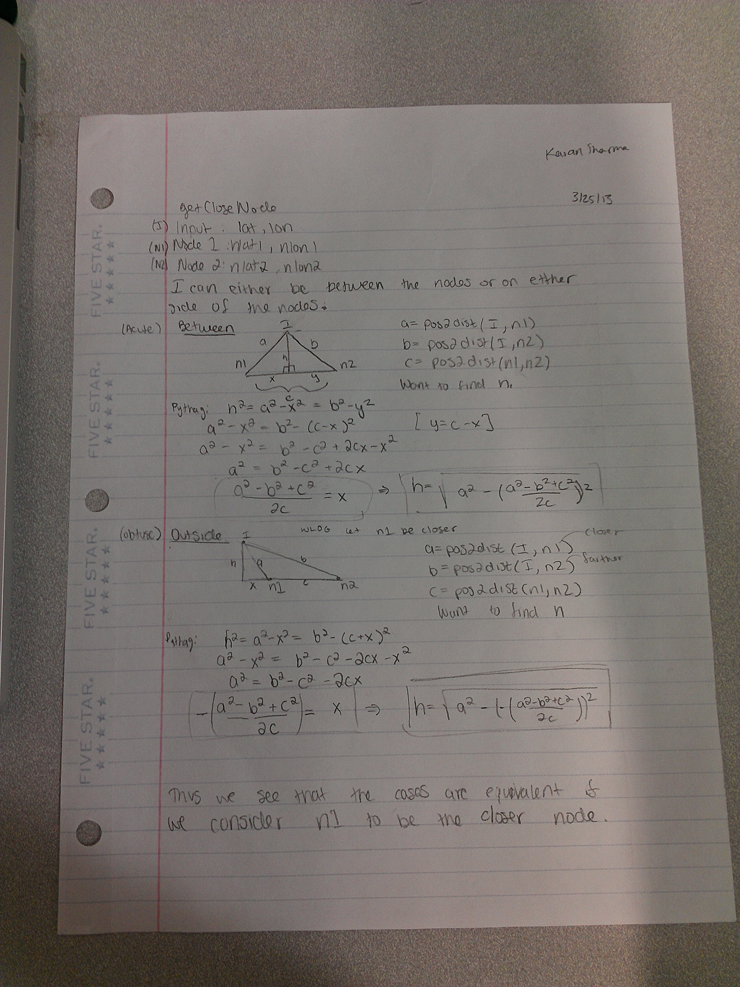

getCloseNode3:

getCloseNode3 is the Matlab function central to the entire snapping process. Its input is a latitude, longitude, tolerance, and limit and its output is the latitude and longitude of the snapped point. Tolerance is effectively the allowed variability in geospatial distance when creating the bounding box for a given input point. In other words, the higher the tolerance value, the bigger the box that is extracting from the osm file, and furthermore, more Ways and Nodes are considered in the snap calculations (with the drawback of increased processing time). The ‘limit’ is simply the maximum tolerance the program will run until. This comes in to when as when no snapped point is found, the program recursively calls itself with a slightly higher tolerance. The limit acts are a max case to prevent an overflow.

Now that you know the basic information about the function, we progress towards a description of the algorithm. So first, the script generates the Matlab container of the bounding box as explained above. At this point, the script traverses through the container via a nested for loop. The outer for loop runs through the Ways and the inner for loop runs through the Nodes of the given Way. So given a Way, the inner for loop first finds the closest Node along that way to the input point and records this closest Nodes’ neighbors. It then calculates the snapped point for these two pairs of Nodes (if both are valid) by the underlying geometry described above. The closer of these two calculated snap points is considered the snapped point of the given Way. This process is done for each of the Ways in the container and the closest snap point of the Ways is considered the correct output. As mentioned previously, if no such snap point is calculated, the script calls itself with a higher tolerance and does so until it reaches the limit tolerance. Upon completion, the script returns (0,0) if no point is found or the geospatial coordinates (lat,lon) of the closest snap point.

snap:

Now with the script of mapping an individual point complete, the next logical step is to be able to snap a collection of points. More specifically, we want to be able to take a text file of raw GPS data in a standard format and create a new file in the same format containing the snapped GPS data. The script that does this is named “snap.m”. Fewer than 20 lines long, the code for the script is natural not very complex. The script takes in the filename of the raw text file as input and outputs the filename of the snapped text file (which is simply –snap.txt instead of just .txt). The scrip then uses the textscan function to scan the text of the file into usable data. From this it goes line-by-line, reading in the longitude and latitude of the point, running getCloseNode3, and outputting the result in the desired format. A tutorial for this function can be found in this folder as “GPS Snapping Tutorial”.

SnapError:

Although the functions described above generate an accurate geometric projection of GPS data, they do not account for error propagation. By this, it means that there is some error on the input GPS data itself (about 5-10 meters) and there also is error on the snapping process itself as there is a positive probability that the error on the point may have caused the function to snap the point onto the wrong street in some cases. Thus, we must account for this error. We account for these errors in a 2-fold error handing process. First, we want to compensate for the geospatial variability a single snapped point would have due to the 5-10 meter error on the input point. Since we know that snapping puts the point on a valid OSM steet, we determine the error to be only 2 meters in the normal direction to account for the width of the street and 10 meters in the direction of the street. This creates an error ellipse around that snapped point that will be the same for all snapped points and is stored as a 2x2 covariance matrix. Now the second part of the error calculation is to weigh the possible streets (ways) the raw GPS point can map to according to the perpendicular distance from the point to the street. We accomplish this by calculating the Gaussian on the 3 closest snapped points based on distance (via a variation of getCloseNode3) and then normalize these 3 values in order to determine the probability of each candidate street. The error is stored in a text file as seen below and can be plotted to generate the plot below.

The Gaussian Function:

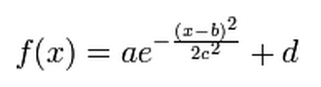

Error Text File:

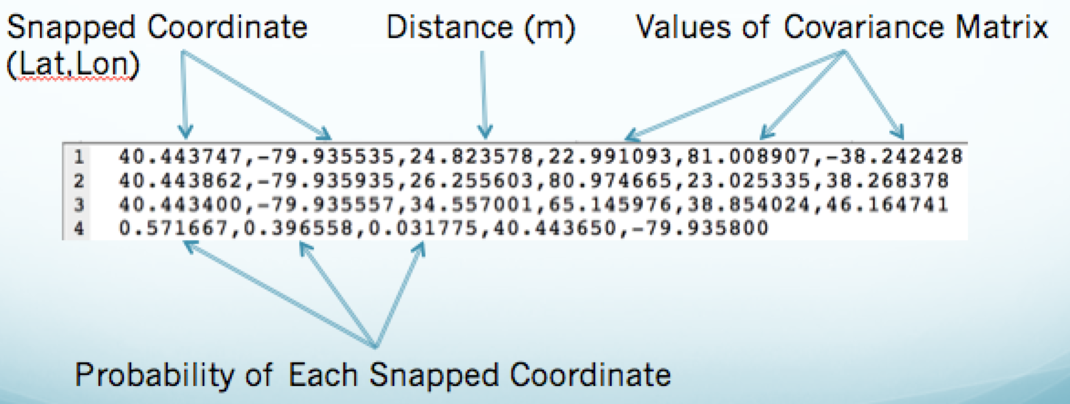

Error Plot:

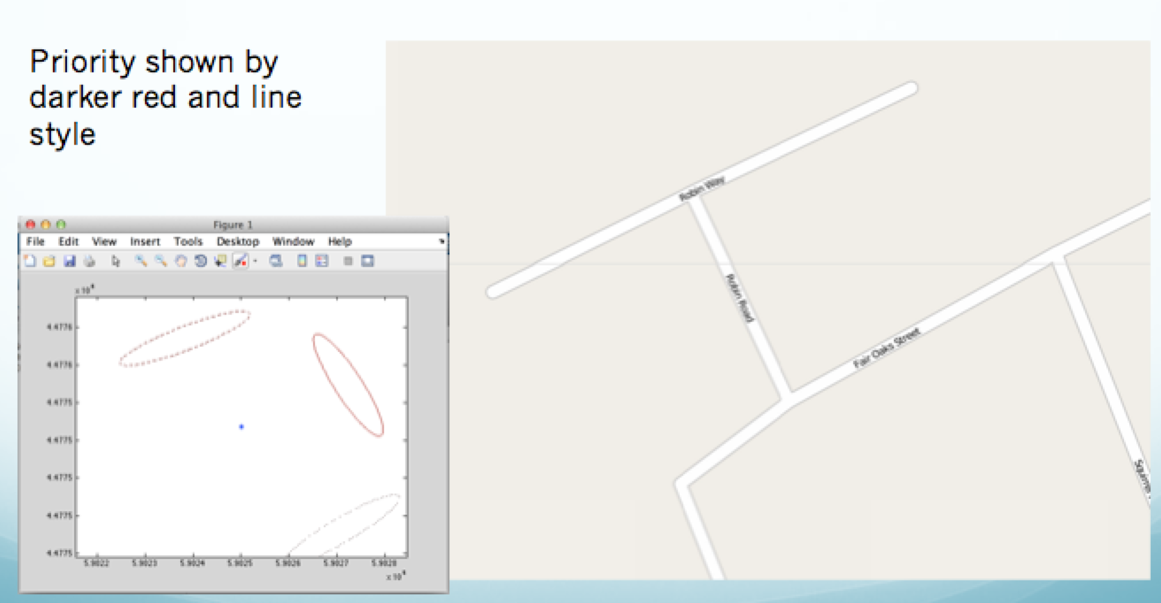

We conclude with several plots of real GPS data snapped using the functions described above.

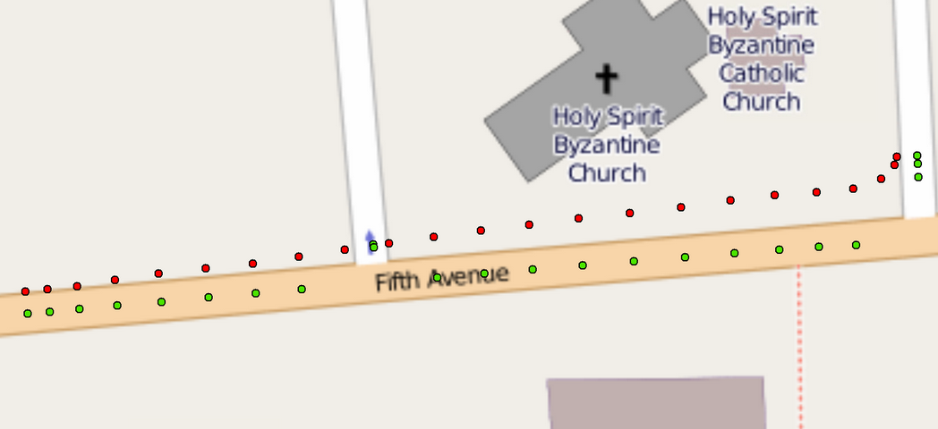

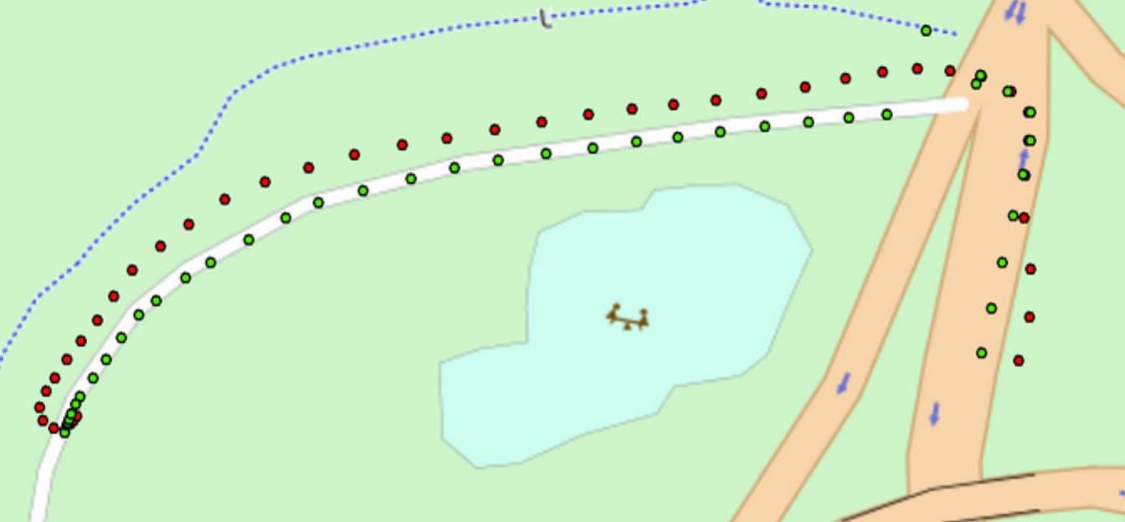

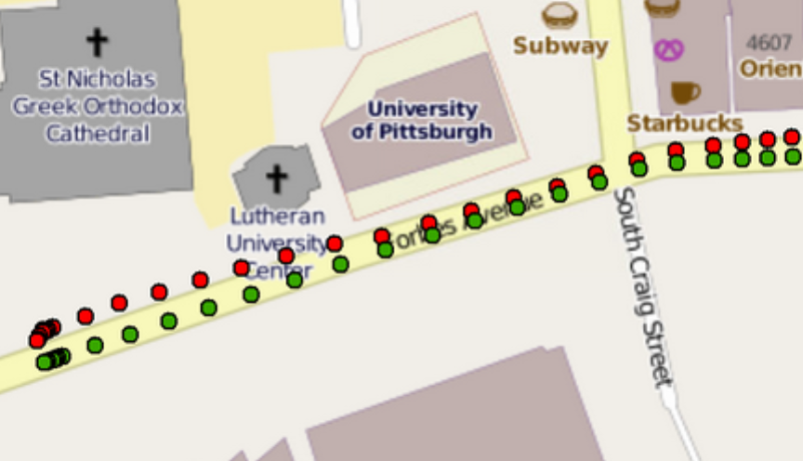

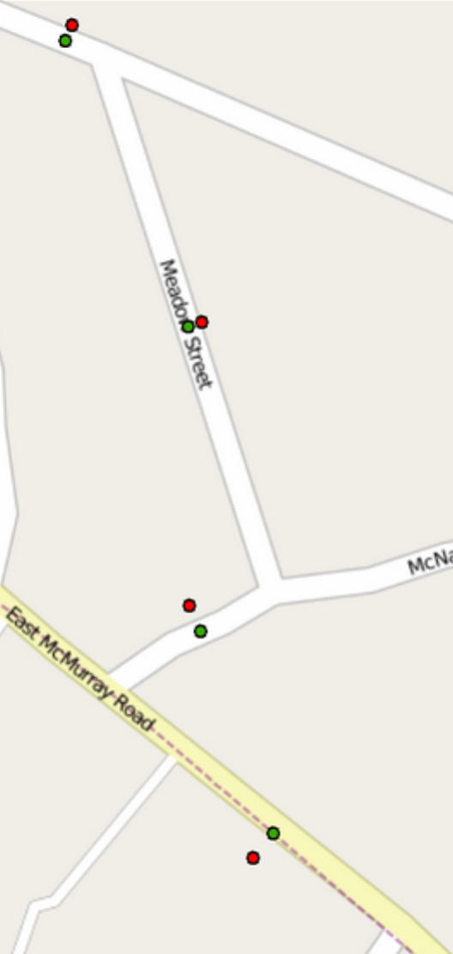

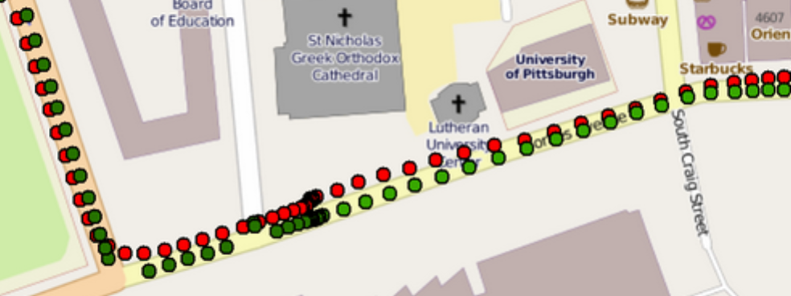

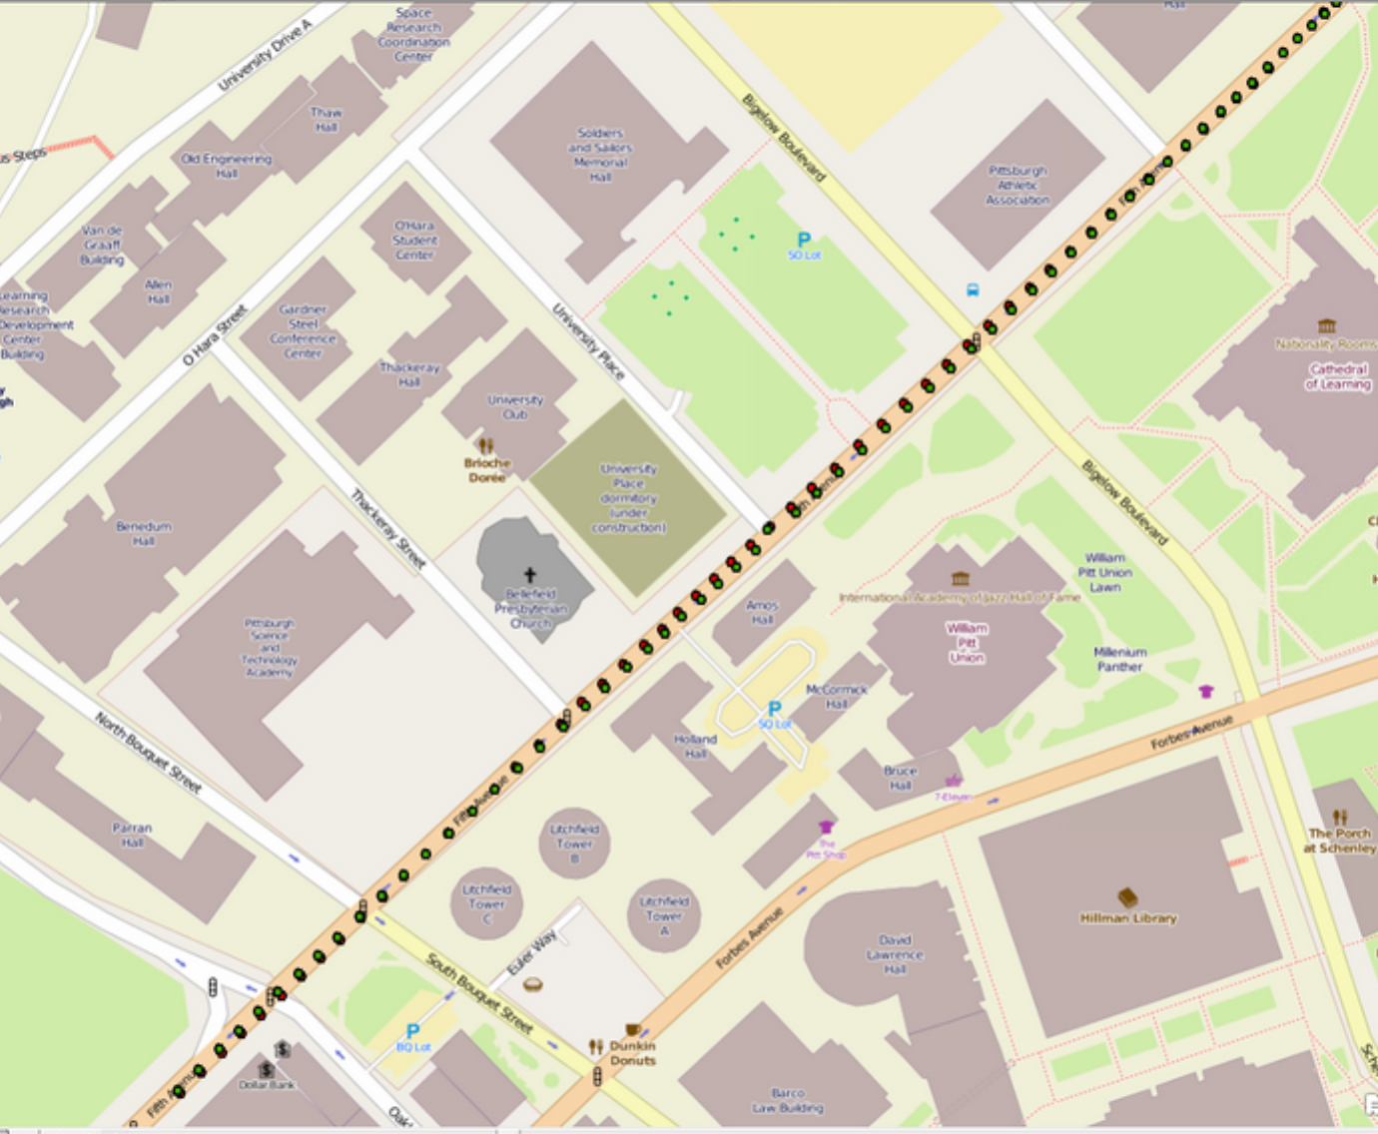

Though the snapping is mostly correct, there are instances where it is not due to non-street ways in OSM, which reinforces the need for error calculations.

